Section 1
Creating a Chart

The Chart feature in Microsoft Excel has been expanded in Office 2000 to create professional charts which can be used for effective delivery and presentation of statistical data. In this section, you will learn how to create the two basic charts supported by Microsoft Excel: the embedded chart and the chart sheet.

Elements of a Chart
In Excel, a chart is developed from worksheet data. It is not necessary to design or layout a chart, define a chart type, or even select a color scheme. All of these factors are decided by Excel and can be changed at any time after the chart’s creation. Shown below is an Excel worksheet with an embedded chart.

Data Series Range
X-Axis Range

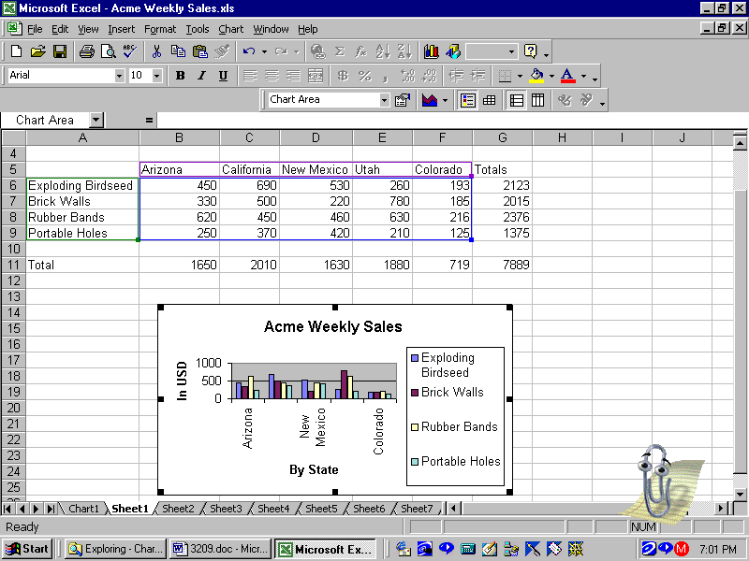
Data Series
Chart Title
Y-Axis
Legend
Legend
Range

X-Axis

Embedded Chart Sheet
When creating a chart, you have a choice of placing that chart on the worksheet as an embedded chart, or creating a separate sheet called a chart. Th Chart Wizard button on the toolbar may be used to create either type of chart while the <F11> key is the easiest way to create a chart sheet.

Chart Sheet
A chart sheet is a separate sheet in the workbook that can be printed separately from the other sheets. The chart is still linked to the data on the worksheet and will be updated automatically when changes are made in the data. Shown below is an example of a chart sheet.

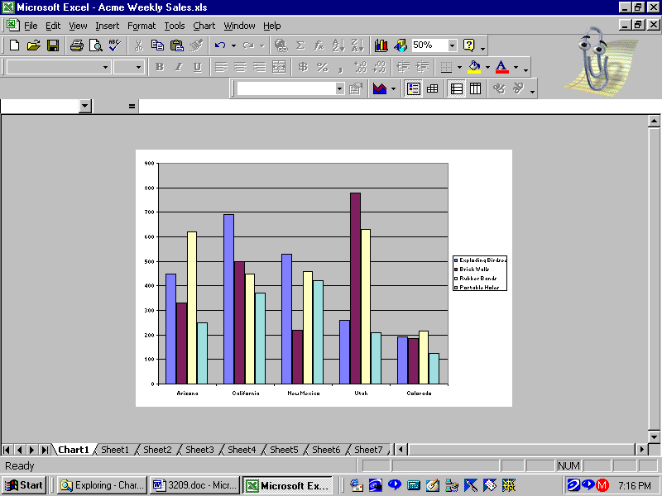

Embedded Chart
An embedded chart is visible when the worksheet is active and can be included in the same print range with the worksheet data. The chart data is linked to the chart and will be updated automatically when changes are made on the worksheet. An embedded chart is displayed below.

Creating Charts
In Microsoft Excel, there are several methods available for generating a chart in an existing worksheet. Three of the methods are listed in the table below.

Menu | Function Key | Toolbar
Insert Chart | <F11> | Chart Wizard button

Chart Sheets
Creating a chart sheet is similar to drawing a chart on a piece of graph paper and placing it into a notebook. In the next exercise, you will create a new workbook and save it as International Comparison. Then you will create a chart sheet.

- Open a new workbook (file).
- Enter the data shown below.
- Save the file as Sales Contest.

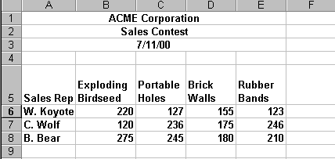

- Select the worksheet data to be charted (A5:E8).
- Press the <F11> function key.
A Chart Sheet appears in the workbook. The sheet tab at the bottom of the window displays Chart 1.
- Save the file.
- Compare your chart with the following illustration.
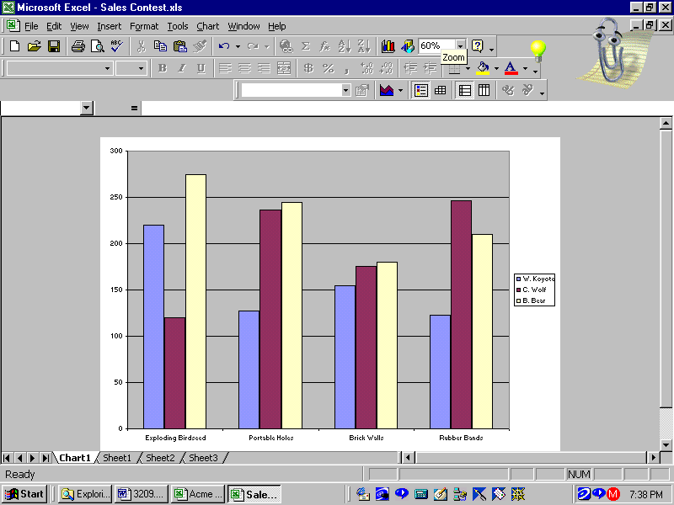
Sheet Tabs

Creating an Embedded Chart

In this exercise, you will use the Chart Wizard to create an embedded chart based on the Sales Contest workbook. You will create the chart by selecting non-contiguous cells for the range. The embedded chart will appear as an object on the same worksheet as the data. It will be necessary to move and size the chart after its creation.

- The file Sales Contest should still be open.
- Click on the worksheet tab Sheet 1.
- In Column F calculate totals for each sales person.
- Save the file and compare to the following.

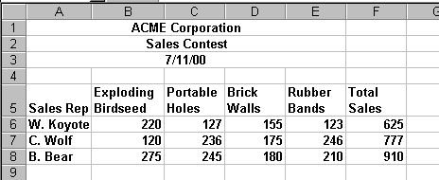

- Select cells A5 through A8.
- Hold the <Ctrl> key on the keyboard and select cells F5 through F8.
Two separate ranges will be selected as shown below.

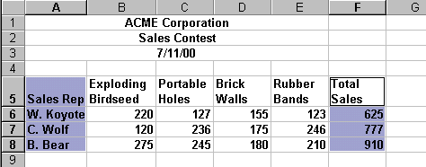

- Click the Chart Wizard button.
The first step of the Chart Wizard dialog box appears.

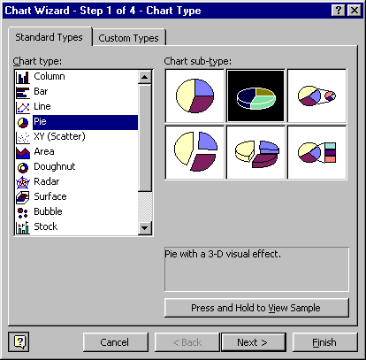

- Under Chart type: select Pie.
- Click on a Chart sub-type: on the right.
In the illustration, the Pie with 3-D visual effect is selected.
- Click [Next>] to move to the next step.
A preview of the chart is displayed in the Step 2 dialog box, as shown in the following illustration.

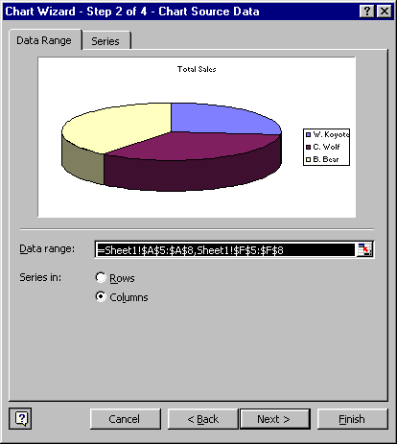

- Click [Next>] to proceed to the next step.
The Step 3 dialog box is displayed.

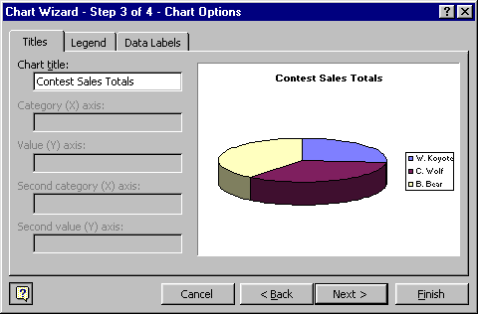

- Click in the Chart title: text box and enter Contest Sales Totals.
- Pause a moment after you type the title text.
The title is updated in the preview window.
- Click [Next>] to proceed to the next step.

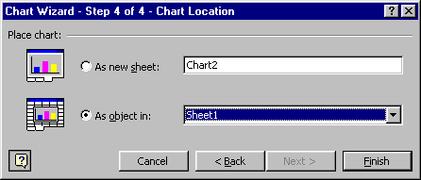

- Click [Finish] to complete the wizard.
The chart is placed on the sheet over the data.

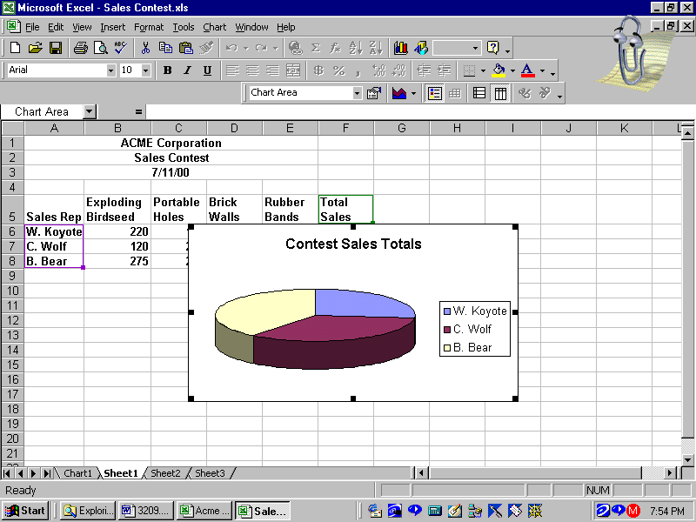
Selection
Handles

- Save the file.

Section 2 - Moving and Sizing Charts
Once an embedded chart is added to a worksheet, it will overlay part of the data. It is necessary to move the chart to a location on the worksheet where it will not hide the original data. To do this, you will use “drag and drop” to reposition the chart on the worksheet.

In the next exercise, you will reposition the chart below the data.

- The chart should be selected. This means that black squares or “selection handles” appear around the chart.
- Point to a blank area inside the chart and drag the chart to begin in cell A10.
The pointer changes to a move icon.
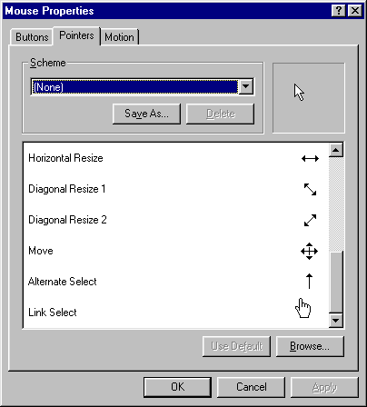
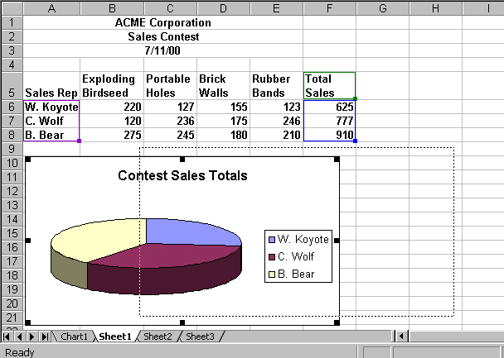
Move Icon

Previewing Charts
Both embedded charts and chart sheets can be displayed in Print Preview before they are sent to the printer. By default, an embedded chart will print on the same page as the worksheet data in portrait orientation. In contrast, a chart sheet will be printed on a separate sheet from the worksheet data in landscape orientation.

Embedded Chart
An embedded chart can be previewed and printed as part of the worksheet, or as a separate item. To preview the embedded chart and worksheet at one time, use the Print Preview feature.

- Click outside the chart.
The chart is no longer selected.
- Click the Preview button.
The worksheet is displayed on a full page in portrait orientation.
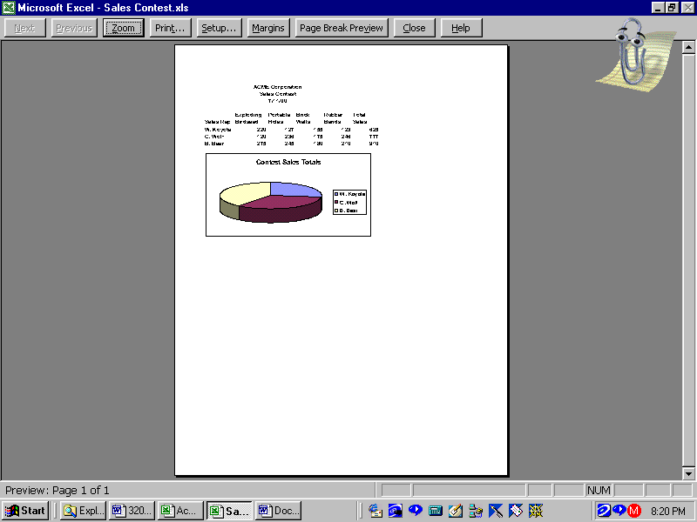
- Click [Close] to close preview.
- Save the file.

Center the Data
Print Preview provides an opportunity to center the data and the chart on the printed page. The Setup button in the Preview Toolbar is a shortcut to the File Print Preview command.

      - Click the Print Preview button on the toolbar.
      - Click the [Setup…] button.
      - Select the Margins tab.

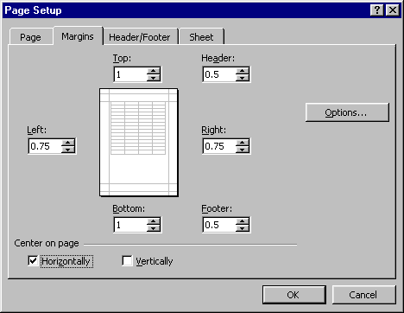

      - Activate the option to Center on page Horizontally.
      - Click [OK].
The data and the chart are centered on the page.
      - Click [Close] to close Print Preview.
      - Save the file.

Print Embedded Charts
When you want to print an embedded chart on a page without the data, you must select the chart before you access the Print command.

      - Click once on the chart to select.
      - Select File Print from the menu (or press <Ctrl> <P>).
      - Verify that the Selected Chart option is selected.

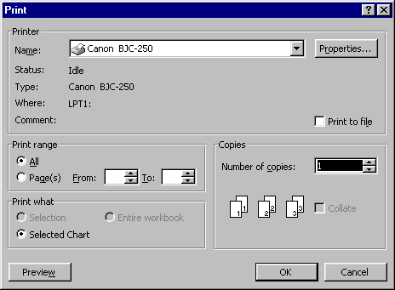

      - Click [OK].

Preview Chart Sheets

- The Sales Contest workbook should still be open.
- Click on the sheet tab for Chart 1.
- Click the Print Preview button.
The chart will be displayed on a sheet of paper in landscape orientation.

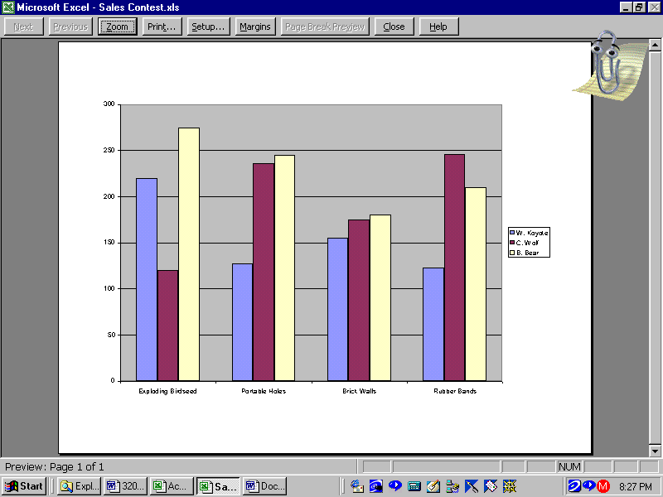

Print Chart Sheets

      - Click the [Print] button on the Previe Toolbar.
The Print dialog box opens.

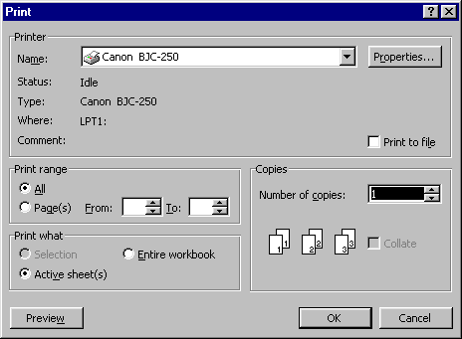

- Verify that the Active Sheet(s) option is selected.
- Click [OK].

Charting Summary Exercises

Part One
- Open Department Sales.xls.
- Save as Department Sales Revised.xls.
- Using the Chart Wizard button, create an embedded column chart.
- Accept the first Chart sub-type.
- Enter the Chart title as Sales by Department.
- Preview the chart.
- Compare your chart with the chart below.

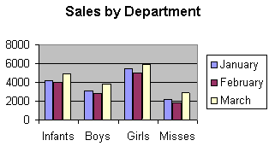

- Move the chart to begin in cell A11.
- Rename the Sheet 1 tab Dept. Sales.
- Save the file.
- Close the file.

Part Two

- Data series are represented in the above chart by ______________.
- A chart that is placed on the worksheet is called an ______________ ________________.
- A chart sheet is a separate sheet in the workbook that can be printed separately from the other sheets in the workbook. ( True / False )
- The Chart Wizard will walk you step by step through creating a chart. ( True / False )
- A chart sheet, by default, is set up to print in ____________ ________________, filling the entire page.
- Data series can be added to the chart simply by selecting the data and __________ it to an embedded chart. You may also use the _______ _______ __________ feature to add a series to a chart sheet.

